Article title: Systematic review and meta-analysis of efficacy and safety of silodosin in treatment of benign prostatic hyperplasia patients with lower urinary tract symptoms
Journal name: International Urology and Nephrology
Authors:
Chi Yuan^{1*}, Zhongyu Jian^{1*}, Yucheng Ma^{1*}, Menghua Wang¹, Qibo Hu¹, Linhu Liu¹, Yushi He¹, Hong Li¹, Kunjie Wang^{1#}
1. Department of Urology, Institute of Urology (Laboratory of Reconstructive Urology), West China Hospital, Sichuan University, Chengdu, Sichuan, People’s Republic of China.

*Chi Yuan, Zhongyu Jian and Yucheng Ma contributed equally to this work.

#Address correspondence to:
Kunjie Wang, MD
Department of Urology, Institute of Urology (Laboratory of Reconstructive Urology), West China Hospital, Sichuan University, No. 37 Guo Xue Xiang, Chengdu, Sichuan, 610041, P.R. China.
Email: wangkj@scu.edu.cn
Tel: +86-189-8060-1848; Fax: +86-028-8542 2451

Table 1 Results of the Begg’s and Egger’s test on meta-analysis

Endpoints | Medication | P value of Begg's Test (continuity corrected) | P value of Egger's test
Efficacy endpoints | Medication | P value of Begg's Test (continuity corrected) | P value of Egger's test
The total IPSS
 | Silodosin VS placebo | 1.000 | 0.870
 | Silodosin VS tamsulosin | 0.263 | 0.144
 | Silodosin VS naftopidil | 0.754 | 0.002
 | Silodosin VS alfuzosin | 0.296 | 0.114
The IPSS voiding subscore
 | Silodosin VS placebo | 1 | 0.747
 | Silodosin VS tamsulosin | 0.734 | 0.758
 | Silodosin VS naftopidil | 0.308 | 0.075
The IPSS storage subscore
 | Silodosin VS placebo | 1 | 0.873
 | Silodosin VS tamsulosin | 0.734 | 0.66
 | Silodosin VS naftopidil | 0.308 | 0.033
Qmax
 | Silodosin VS placebo | 1 | -
 | Silodosin VS tamsulosin | 0.583 | 0.361
 | Silodosin VS naftopidil | 1 | 0.499
 | Silodosin VS alfuzosin | 0.296 | 0.025
Prostate size
 | Silodosin VS tamsulosin | 0.734 | 0.62
PVR
 | Silodosin VS tamsulosin | 0.536 | 0.663
 | Silodosin VS naftopidil | 0.707 | 0.703
QoL
 | Silodosin VS placebo | 1 | -
 | Silodosin VS tamsulosin | 0.428 | 0.015
 | Silodosin VS naftopidil | 0.529 | 0.001
 | Silodosin VS alfuzosin | 0.296 | 0.46
Safety endpoints
Retrograde ejaculation
 | Silodosin VS placebo | 1 | 0.726
 | Silodosin VS tamsulosin | 0.707 | 0.69
 | Silodosin VS naftopidil | 0.296 | 0.117
Dizziness & vertigo
 | Silodosin VS placebo | 1 | 0.721
 | Silodosin VS tamsulosin | 0.462 | 0.235
 | Silodosin VS alfuzosin | 1 | -
Headache
 | Silodosin VS placebo | 1 | 0.286
 | Silodosin VS tamsulosin | - | -
Upper respiratory tract infection
 | Silodosin VS tamsulosin | 1 | -
Drug-related adverse events
 | Silodosin VS placebo | 0.296 | 0.326
 | Silodosin VS tamsulosin | 0.734 | 0.666
Any adverse events
 | Silodosin VS placebo | 1 | -
 | Silodosin VS tamsulosin | 0.027 | 0.001
 | Silodosin VS naftopidil | - | -
 | Silodosin VS alfuzosin | 1 | -
Postural hypotension
 | Silodosin VS placebo | - | -
 | Silodosin VS tamsulosin | 1 | -
Thirst
 | Silodosin VS placebo | 1 | -
Diarrhea
 | Silodosin VS placebo | 1 | 0.151
Nasopharyngitis
 | Silodosin VS placebo | 1 | -
Nasal congestion
 | Silodosin VS placebo | 1 | -

Table 2 Design of the evaluated studies and demographic and baseline characteristics of the included patients

Authors | Arms | Study design | Treatment duration | Blinding method | Mean patients age (year) | Mean prostate volume (ml) | Mean baseline IPSS score | Mean baseline IPSS storage subscore | Mean baseline IPSS voiding subscore | Mean baseline QoL IPSS item | Mean baseline Qmax (mL/s) | Mean baseline PVR (mL)
Kawabe, 2006 [18] | Silodosin 8 mg (n= 175) | RCT | 12 weeks | Double blind | 65.4 | 36 | 17.1 | 6.4 | 10.8 | 4.9 | 9.9 | 28.1
Kawabe, 2006 [18] | Tamsulosin 0.2 mg (n= 192) | RCT | 12 weeks | Double blind | 65.6 | 35.7 | 17 | 6.2 | 10.8 | 4.7 | 9.4 | 29
Kawabe, 2006 [18] | Placebo (n = 89) | RCT | 12 weeks | Double blind | 65 | 35.2 | 17.1 | 6.3 | 10.9 | 4.7 | 9.9 | 28
Marks, 2009 [19] | Silodosin 8 mg (n= 466) | Pooled analysis of 2 RCTs | 12 weeks | Double blind | 64.6 | - | 21.3 | 9.3 | 12 | - | 8.7 | -
Marks, 2009 [19] | Placebo (n = 457) | Pooled analysis of 2 RCTs | 12 weeks | Double blind | 64.7 | - | 21.3 | 9.3 | 12 | - | 8.9 | -
Chapple, 2011 [20] | Silodosin 8 mg (n= 371) | RCT | 12 weeks | Double blind | 65.8 | - | 19.1 | 7.9 | 11.3 | 3.9 | 10.7 | -
Chapple, 2011 [20] | Tamsulosin 0.4 mg (n= 376) | RCT | 12 weeks | Double blind | 65.9 | - | 18.9 | 7.9 | 11 | 3.9 | 10.2 | -
Chapple, 2011 [20] | Placebo (n = 185) | RCT | 12 weeks | Double blind | 66 | - | 19.3 | 8 | 11.3 | 4 | 10.3 | -
Yu, 2011 [21] | Silodosin 8 mg (n= 87) | RCT | 12 weeks | Double blind | 67.5 | 44.8 | 19.3 | 7.1 | 12.1 | 3.8 | 10.3 | -
Yu, 2011 [21] | Tamsulosin 0.2 mg (n= 83) | RCT | 12 weeks | Double blind | 65 | 38.2 | 19.8 | 6.9 | 13 | 3.7 | 10.6 | -
Nusrat, 2016 [22] | Silodosin 8 mg (n= 30) | RCT | 12 weeks | Single blind | 64.4 | 40 | 18 | - | - | 4.9 | 15.1 | 55.2
Nusrat, 2016 [22] | Tamsulosin 0.4 mg (n= 30) | RCT | 12 weeks | Single blind | 63.6 | 38.7 | 18.4 | - | - | 4.88 | 15.3 | 55.9
Pande, 2014 [23] | Silodosin 8 mg (n= 26) | RCT | 12 weeks | Single blind | 61.4 | 42 | 18.4 | - | - | - | 15.5 | 49.2
Pande, 2014 [23] | Tamsulosin 0.4 mg (n= 27) | RCT | 12 weeks | Single blind | 62.6 | 35.6 | 18.4 | - | - | - | 15.9 | 58.9
Manjunatha, 2016 [24] | Silodosin 8 mg (n= 30) | RCT | 12 weeks | Open label | 64 | 40.57 | 15.93 | - | - | 4.7 | 10.03 | -
Manjunatha, 2016 [24] | Tamsulosin 0.4 mg (n= 30) | RCT | 12 weeks | Open label | 63.6 | 40.33 | 21.63 | - | - | 4.63 | 9.58 | -
Manjunatha, 2016 [24] | Alfuzosin 10mg (n= 30) | RCT | 12 weeks | Open label | 63.43 | 44.43 | 19.2 | - | - | 4.73 | 10.18 | -
Amulya, 2019 [25] | Silodosin 8 mg (n= 32) | RCT | 12 weeks | Open label | 65.25 | 62.66 | 26.78 | - | - | 4.22 | 7.297 | 46.88
Amulya, 2019 [25] | Tamsulosin 0.4 mg (n= 34) | RCT | 12 weeks | Open label | 65.29 | 58.08 | 29 | - | - | 4.35 | 7.403 | 45
Siddangouda, 2017 [26] | Silodosin 8 mg (n= 80) | RCT | 12 weeks | Single blind | 65.8 | 44.5 | 14.1 | - | - | - | 10.8 | 91.1
Siddangouda, 2017 [26] | Tamsulosin 0.4 mg (n= 80) | RCT | 12 weeks | Single blind | 64.5 | 42.3 | 14.4 | - | - | - | 11.3 | 92.6
Novara, 2014 [27] | Silodosin 8 mg (n= 847) | Pooled analysis of 3 RCTs | 12 weeks | Double blind | 64.9 | - | 20.3 | 8.7 | 11.7 | 3.9 | 9 | -
Novara, 2014 [27] | Placebo (n = 647) | Pooled analysis of 3 RCTs | 12 weeks | Double blind | 64.7 | - | 20.7 | 8.9 | 11.8 | 4 | 8.9 | -
Manohar, 2017 [28] | Silodosin 8 mg (n= 93) | RCT | 12 weeks | Double blind | 59.1 | 35.18 | 14.27 | - | - | 2.47 | 12.13 | 53.61
Manohar, 2017 [28] | Tamsulosin 0.4 mg (n= 89) | RCT | 12 weeks | Double blind | 58.47 | 33.82 | 16.27 | - | - | 2.4 | 11.75 | 41.88
Manohar, 2017 [28] | Alfuzosin 10mg (n=87) | RCT | 12 weeks | Double blind | 56.9 | 37.76 | 16.23 | - | - | 2.37 | 12.69 | 44.74
Yokoyama, 2011 [29] | Silodosin 8 mg (n= 45) | RCT | 12 weeks | - | 70.2 | 33.3 | 18.7 | 8.07 | 8.27 | 4.5 | 9.03 | 57.6
Yokoyama, 2011 [29] | Tamsulosin 0.2 mg (n= 45) | RCT | 12 weeks | - | 71.5 | 32.5 | 18 | 7.82 | 7.64 | 4.49 | 8.56 | 29.7
Yokoyama, 2011 [29] | Naftopidi 50mg (n=46) | RCT | 12 weeks | - | 69.1 | 35 | 17.4 | 7.83 | 7.47 | 4.55 | 8.63 | 39.1
Matsukawa, 2016 [30] | Silodosin 8 mg (n= 157) | RCT | 12 weeks | Open label | 70.6 | 39.6 | 18.8 | 8.5 | 10.3 | 4.8 | 8.2 | 41
Matsukawa, 2016 [30] | Naftopidi 75mg (n=157) | RCT | 12 weeks | Open label | 70.3 | 38.6 | 18.9 | 8.6 | 10.3 | 4.9 | 8.4 | 44
Shirakawa,  2012 [31] | Silodosin 8 mg (n= 34) | RCT | 8 weeks | Open label | 70 | 35.8 | 18.2 | 7.2 | 8.8 | 4.4 | 9.4 | 48.5
Shirakawa,  2012 [31] | Naftopidi 50mg (n=32) | RCT | 8 weeks | Open label | 70.5 | 43.8 | 17 | 6.9 | 7.5 | 4.3 | 11.6 | 65.1
Yamaguchi, 2013 [32] | Silodosin 8 mg (n= 53) | RCT | 12 weeks | - | 69.3 | 33.2 | 16.9 | 7.5 | 7.1 | 4.6 | 10.4 | 42.9
Yamaguchi, 2013 [32] | Naftopidi 75 mg (n= 44) | RCT | 12 weeks | - | 70 | 39.5 | 18.9 | 8.4 | 8 | 4.8 | 9.9 | 59.9
Choo, 2014 [33] | Silodosin 8 mg once-daily (n= 205) | RCT | 12 weeks | Double blind | 63.84 | 34.55 | 18.61 | 6.85 | 11.76 | 4.4 | 10.58 | 39.65
Choo, 2014 [33] | Silodosin 4 mg twice-daily (n= 202) | RCT | 12 weeks | Double blind | 63.97 | 34.11 | 19.44 | 7.5 | 11.94 | 4.43 | 10.33 | 36.98
Seki, 2015 [34] | Silodosin 4 mg once-daily (n= 95) | RCT | 12 weeks | Open label | 70.8 | 31.5 | 20.5 | 9.4 | 8.3 | 4.9 | 9.1 | 54.8
Seki, 2015 [34] | Silodosin 4 mg twice-daily (n= 93) | RCT | 12 weeks | Open label | 71.9 | 37.5 | 19.4 | 8.7 | 8.4 | 4.8 | 10.7 | 46
Yoshihisa, 2016 [35] | Silodosin 8 mg (n= 53) | RCT | 12 weeks | Open label | 70 | 47.3 | 18.6 | - | - | 4.8 | 7.8 | -
Yoshihisa, 2016 [35] | Silodosin 8 mg and propiverine 20 mg (n= 51) | RCT | 12 weeks | Open label | 70.7 | 44.1 | 18.4 | - | - | 4.9 | 7.9 | -

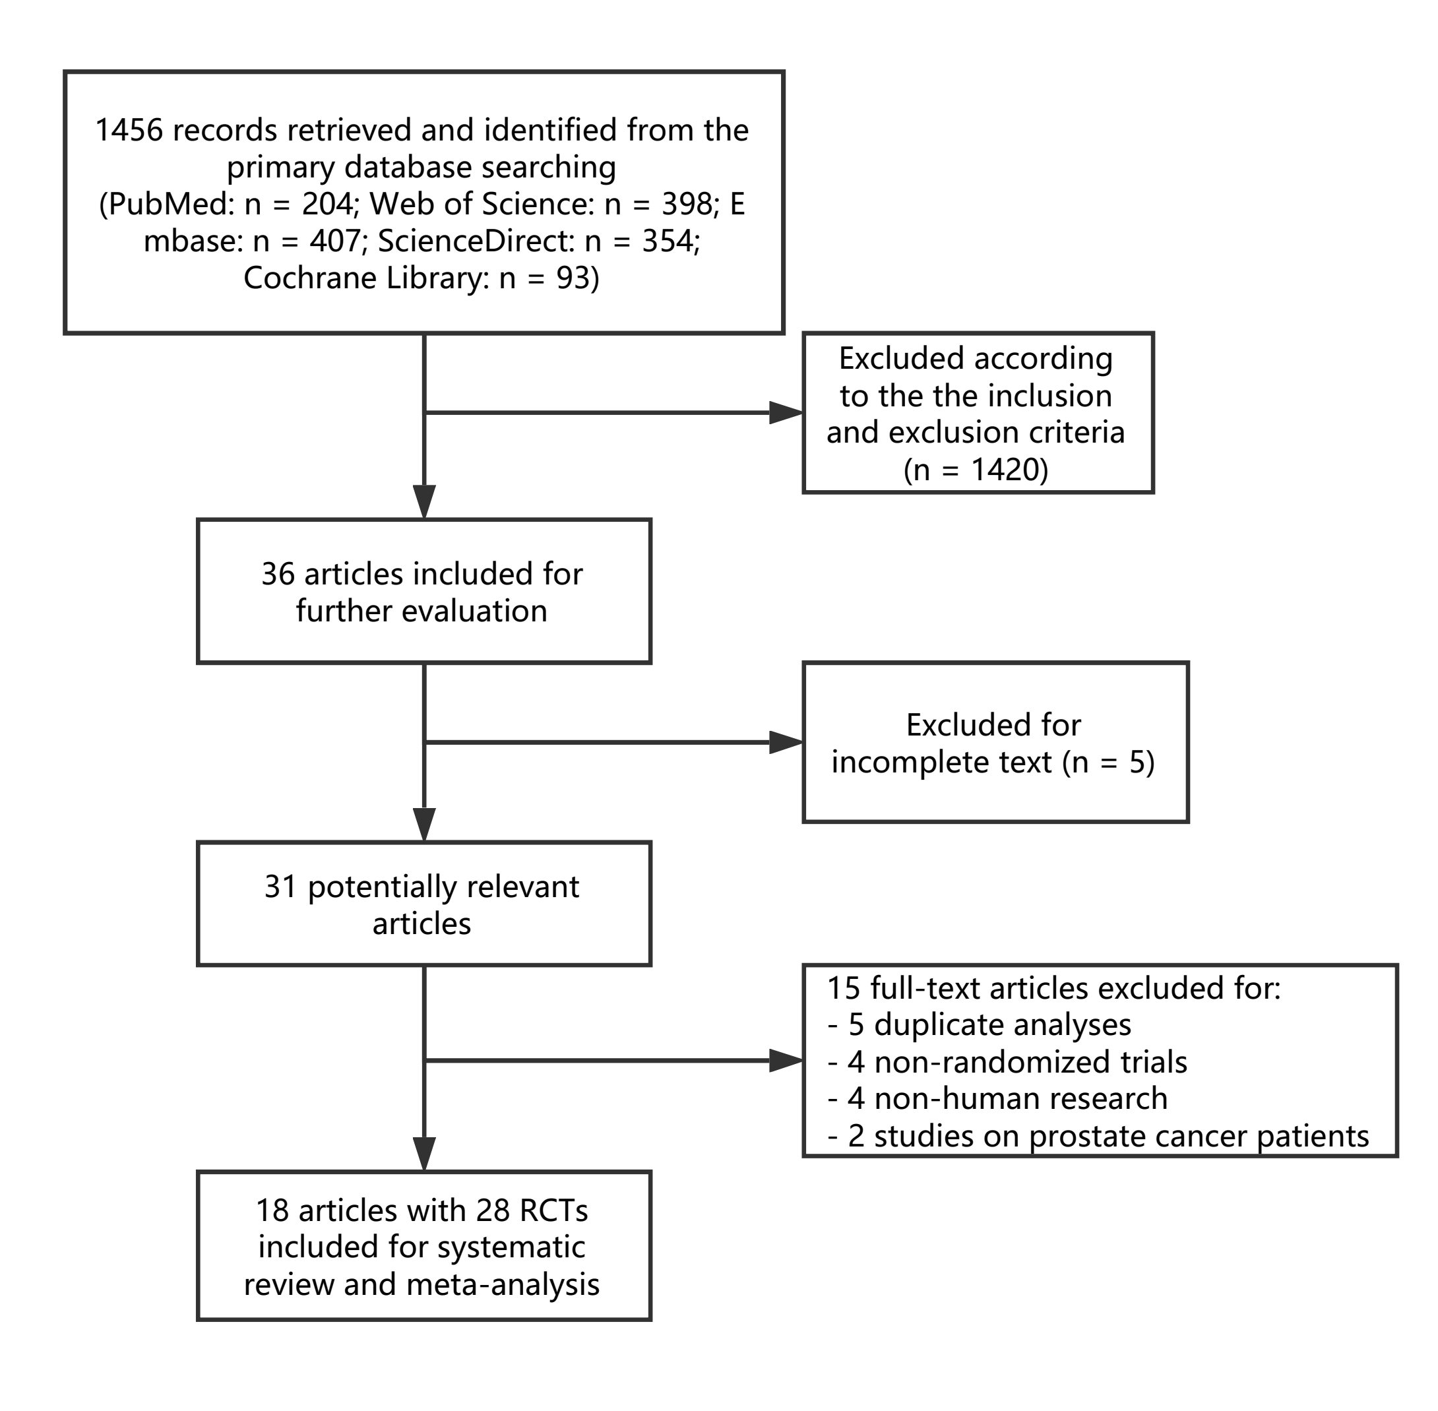
Fig. 1 Flow diagram of the systematic review and meta-analysis.

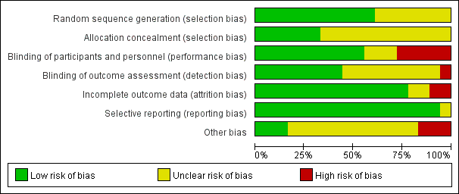
Fig. 2 Risks of bias of included trials.
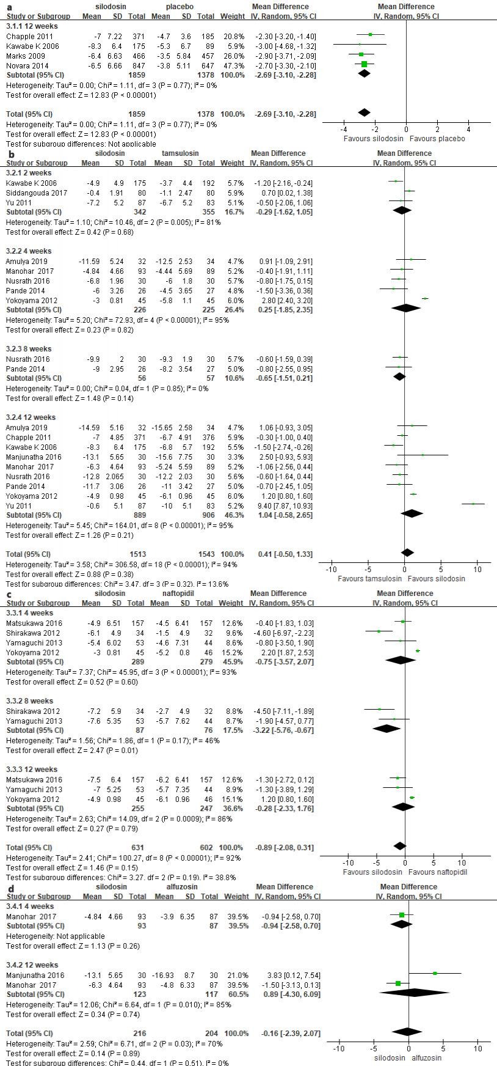
Fig. 3 Results of the meta-analysis on the change from baseline for the total IPSS at different time points in silodosin compared with placebo (a), tamsulosin (b), naftopidil (c) and alfuzosin (d), respectively. Statistically significant difference was found between silodosin and naftopidil in the change of total IPSS at 8 weeks from the start of the treatment (P < 0.05).
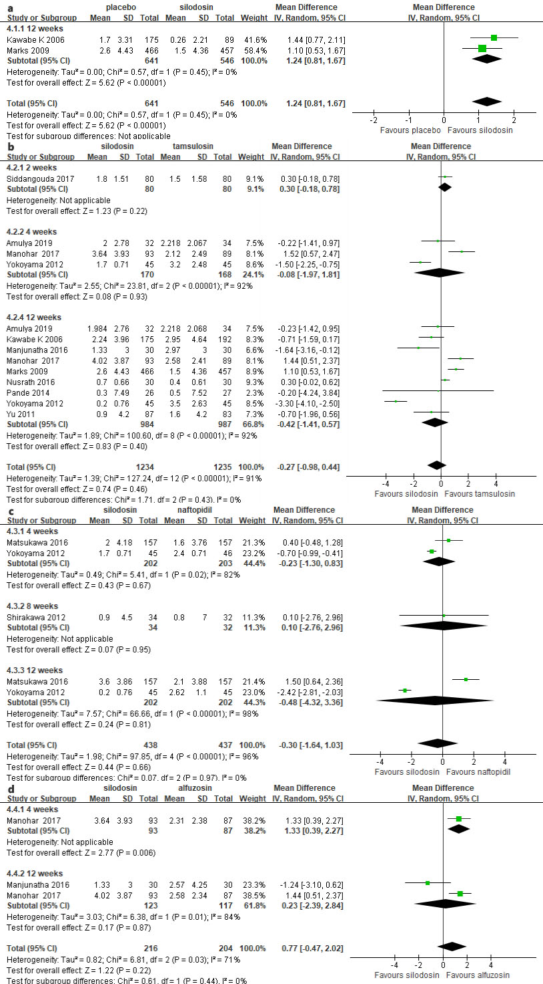
Fig. 4 Results of the meta-analysis on the change from baseline for the Qmax at different time points in silodosin compared with placebo (a), tamsulosin (b), naftopidil (c) and alfuzosin (d), respectively. Statistically significant difference was found in silodosin compared with alfzosin at 4 weeks from the start of the treatment (P < 0.05).
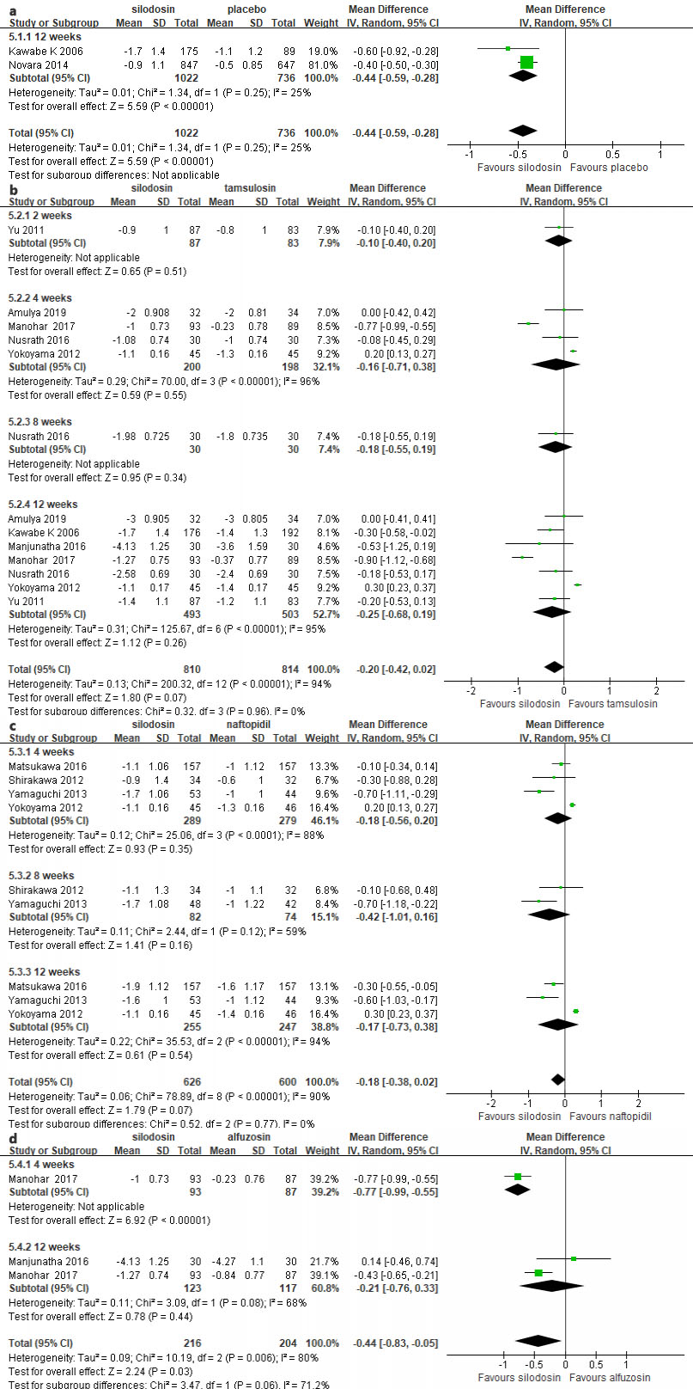
Fig. 5 Results of the meta-analysis on the change from baseline for QoL at different time points in silodosin compared with placebo (a), tamsulosin (b), naftopidil (c) and alfuzosin (d), respectively. No statistically significant differences were found in silodosin compared with tamsulosin and naftopidil in Qol changes at all time points (P > 0.05).

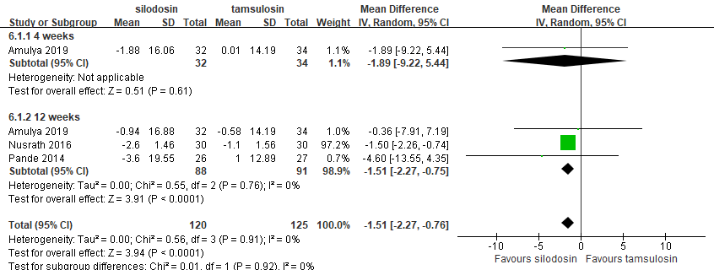
Fig. 6 Result of the meta-analysis on the change from baseline for prostate size at different time points in silodosin compared with tamsulosin. Statistically significant difference was found at 12 weeks from the start of the treatment (P < 0.05).
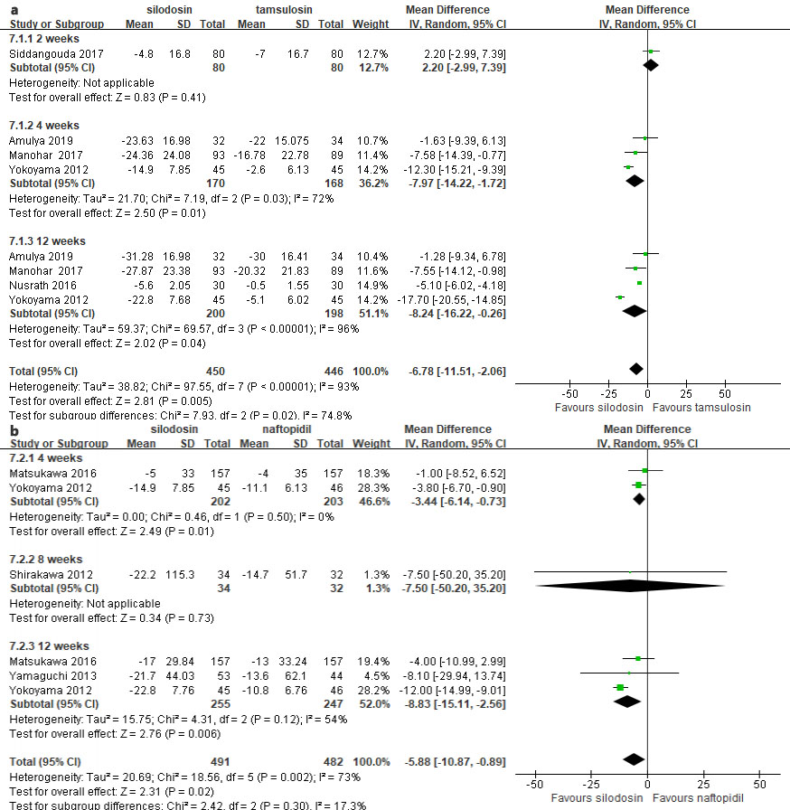
Fig. 7 Results of the meta-analysis on the change from baseline for PVR at different time points in silodosin compared with tamsulosin (a) and naftopidil (b), respectively. Statistically significant differences were found in silodosin compared with tamsulosin and naftopidil at 4 and 12 weeks from the start of the treatment (P < 0.05).

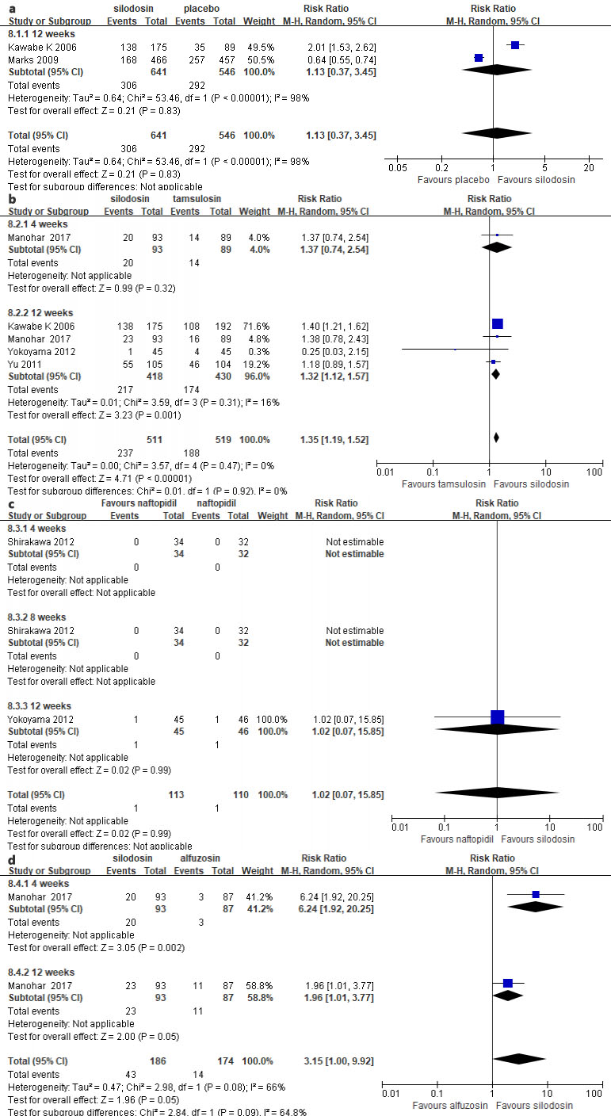
Fig. 8 Results of the meta-analysis on the overall adverse event rate at different time points in silodosin compared with placebo (a), tamsulosin (b), naftopidil (c) and alfuzosin (d), respectively. Statistically significant differences were found in silodosin compared with placebo at 4 and 12 weeks from the start of the treatment (P < 0.05).

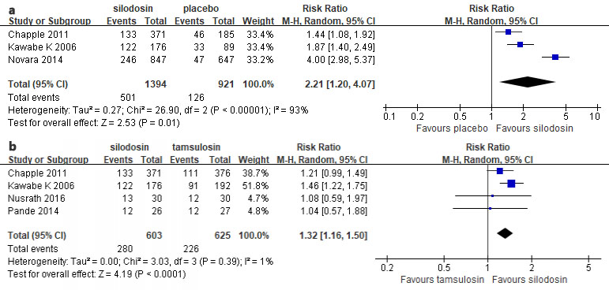
Fig. 9 Results of the meta-analysis on the incidence of drug-related adverse events at 12 weeks from the start of the treatment in silodosin compared with placebo (a) and tamsulosin (b), respectively. Statistically significant differences were found in both two groups (P < 0.05).

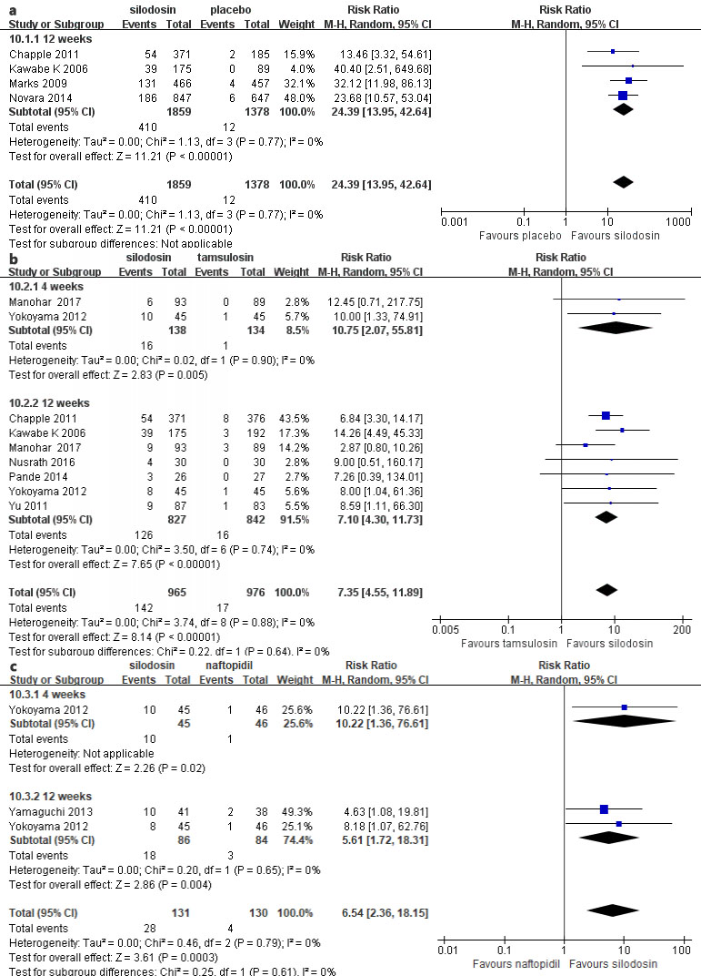
Fig. 10 Results of the meta-analysis on the incidence of retrograde ejaculation at different time points in silodosin compared with placebo (a), tamsulosin (b) and naftopidil (c), respectively. Statistically significant differences were found in all three groups at all time points (P < 0.05).

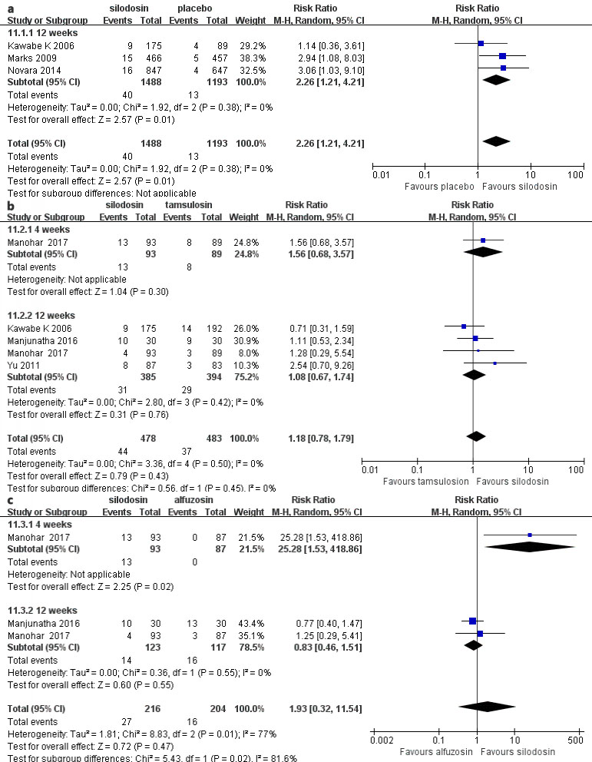
Fig. 11 Results of the meta-analysis on the incidence of dizziness and vertigo at different time points in silodosin compared with placebo (a), tamsulosin (b) and alfuzosin (c), respectively. Statistically significant difference was found in silodosin compared with alfuzosin at 4 weeks from the start of the treatment (P < 0.05).

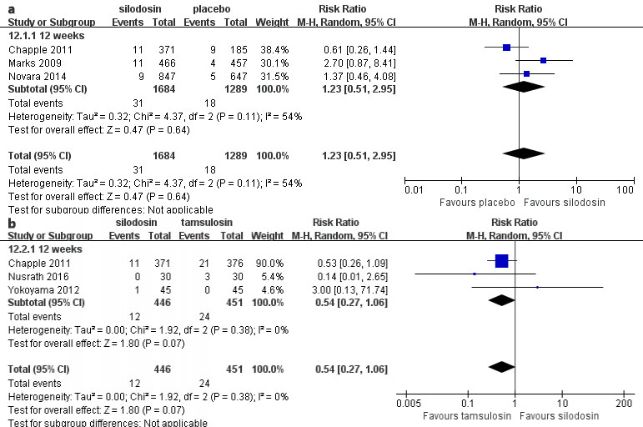
Fig. 12 Results of the meta-analysis on the incidence of headache at 12 weeks from the start of the treatment in silodosin compared with placebo (a) and tamsulosin (b), respectively. Statistically significant difference was found in silodosin compared with tamsulosin (P < 0.05).

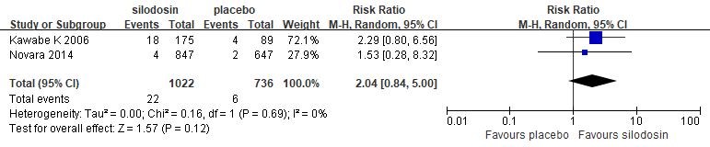
Fig. 13 Results of the meta-analysis on the incidence of thirst at 12 weeks from the start of the treatment in silodosin compared with placebo. No statistically significant difference was found (P > 0.05).

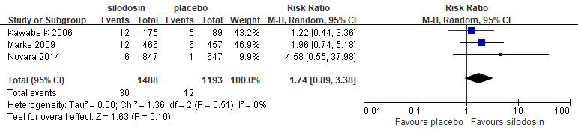
Fig. 14 Results of the meta-analysis on the incidence of diarrhea at 12 weeks from the start of the treatment in silodosin compared with placebo. No statistically significant difference was found (P > 0.05).

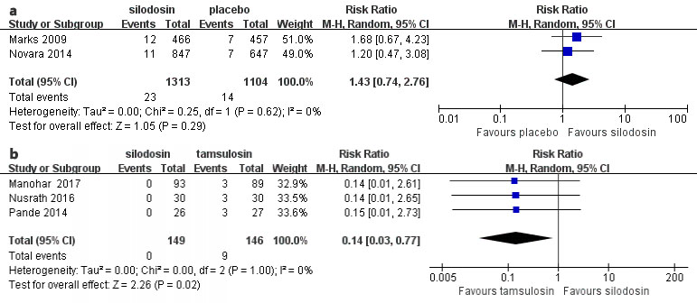
Fig. 15 Results of the meta-analysis on the incidence of postural hypotension at 12 weeks from the start of the treatment in silodosin compared with placebo (a) and tamsulosin (b), respectively. Statistically significant difference was found in silodosin compared with tamsulosin (P < 0.05).

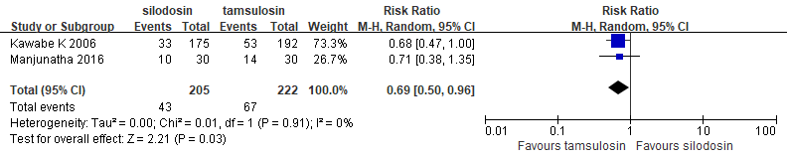
Fig. 16 Results of the meta-analysis on the incidence of upper respiratory tract infection at 12 weeks from the start of the treatment in silodosin compared with tamsulosin. Statistically significant difference was found (P < 0.05).

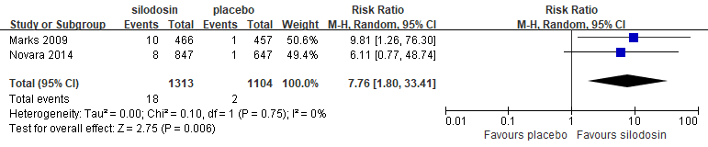
Fig. 17 Results of the meta-analysis on the incidence of nasal congestion at 12 weeks from the start of the treatment in silodosin compared with placebo. Statistically significant difference was found (P < 0.05).

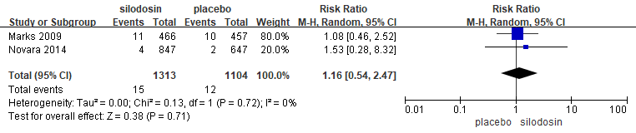
Fig. 18 Results of the meta-analysis on the incidence of nasopharyngitis at 12 weeks from the start of the treatment in silodosin compared with placebo. No statistically significant difference was found (P > 0.05).

